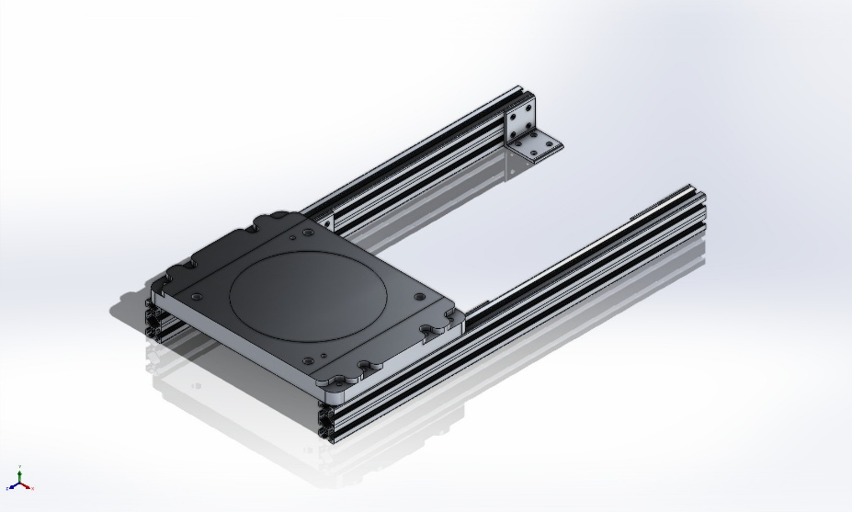 | Simulation of Simplified_Mount_Frame_IRB1200  Date: 07 October 2025  Designer: Solidworks  Study name: Static 1  Analysis type: Static  Table of Contents  Description 1  Assumptions 2  Model Information 3  Study Properties 13  Units 13  Material Properties 14  Loads and Fixtures 15  Connector Definitions 16  Interaction Information 17  Mesh information 18  Sensor Details 19  Resultant Forces 20  Beams 20  Study Results 21  Conclusion 24

Description
No Data

Assumptions

Model Information

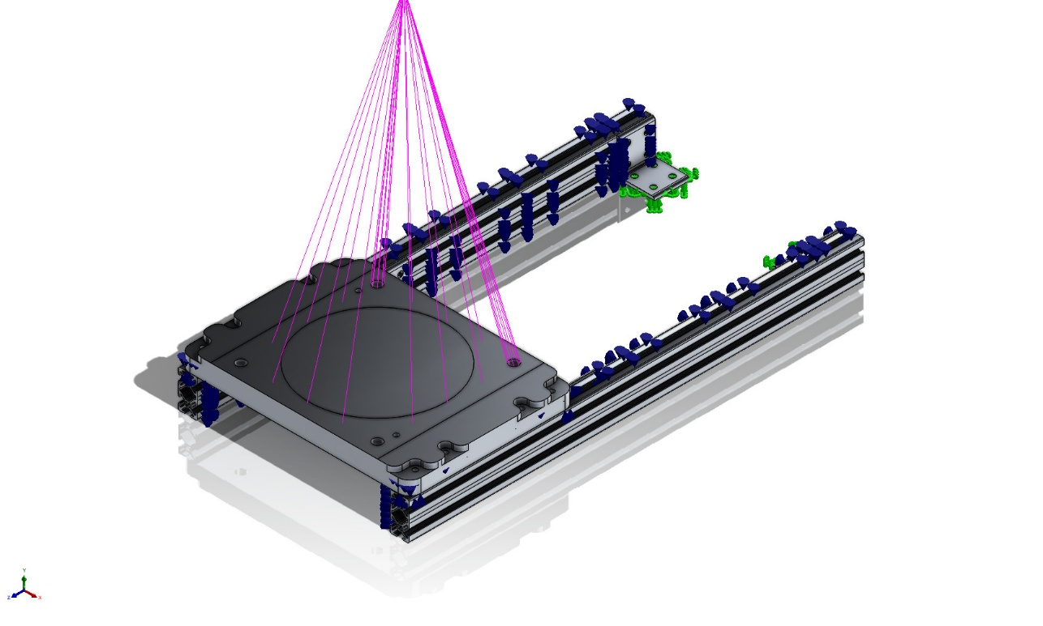
Model name: Simplified_Mount_Frame_IRB1200
Current Configuration: Default
Solid Bodies
Document Name and Reference | Treated As | Volumetric Properties | Document Path/Date Modified
CirPattern1  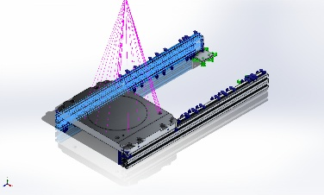 | Solid Body | Mass:0.746171 kg  Volume:0.00027636 m^3  Density:2,700 kg/m^3  Weight:7.31247 N | C:\Users\Lucas\Documents\Projects\Co_Printing\RAAM\Layout\2550_L320T-slot_6575N411.SLDPRT  Oct 7 11:46:51 2025
CirPattern1  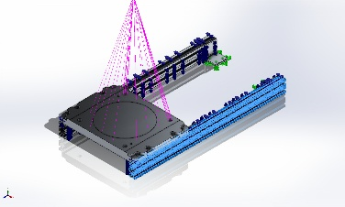 | Solid Body | Mass:0.746171 kg  Volume:0.00027636 m^3  Density:2,700 kg/m^3  Weight:7.31247 N | C:\Users\Lucas\Documents\Projects\Co_Printing\RAAM\Layout\2550_L320T-slot_6575N411.SLDPRT  Oct 7 11:46:51 2025
LPattern6[2] | Solid Body | Mass:0.00150872 kg  Volume:5.58786e-07 m^3  Density:2,700 kg/m^3  Weight:0.0147855 N | C:\Users\Lucas\Documents\Projects\Co_Printing\RAAM\Layout\Fasteners\4844N114_T-Slotted Framing Structural Bracket.SLDPRT  Oct 7 11:46:52 2025
LPattern7[3] | Solid Body | Mass:0.00104745 kg  Volume:3.87945e-07 m^3  Density:2,699.99 kg/m^3  Weight:0.010265 N | C:\Users\Lucas\Documents\Projects\Co_Printing\RAAM\Layout\Fasteners\4844N114_T-Slotted Framing Structural Bracket.SLDPRT  Oct 7 11:46:52 2025
LPattern7[4] | Solid Body | Mass:0.00104745 kg  Volume:3.87945e-07 m^3  Density:2,699.99 kg/m^3  Weight:0.010265 N | C:\Users\Lucas\Documents\Projects\Co_Printing\RAAM\Layout\Fasteners\4844N114_T-Slotted Framing Structural Bracket.SLDPRT  Oct 7 11:46:52 2025
LPattern7[2] | Solid Body | Mass:0.00104745 kg  Volume:3.87945e-07 m^3  Density:2,699.99 kg/m^3  Weight:0.010265 N | C:\Users\Lucas\Documents\Projects\Co_Printing\RAAM\Layout\Fasteners\4844N114_T-Slotted Framing Structural Bracket.SLDPRT  Oct 7 11:46:52 2025
LPattern1[1] | Solid Body | Mass:0.00150872 kg  Volume:5.58786e-07 m^3  Density:2,700 kg/m^3  Weight:0.0147855 N | C:\Users\Lucas\Documents\Projects\Co_Printing\RAAM\Layout\Fasteners\4844N114_T-Slotted Framing Structural Bracket.SLDPRT  Oct 7 11:46:52 2025
LPattern7[1] | Solid Body | Mass:0.00104745 kg  Volume:3.87945e-07 m^3  Density:2,699.99 kg/m^3  Weight:0.010265 N | C:\Users\Lucas\Documents\Projects\Co_Printing\RAAM\Layout\Fasteners\4844N114_T-Slotted Framing Structural Bracket.SLDPRT  Oct 7 11:46:52 2025
Body-Move/Copy3[2] | Solid Body | Mass:0.00150872 kg  Volume:5.58786e-07 m^3  Density:2,700 kg/m^3  Weight:0.0147855 N | C:\Users\Lucas\Documents\Projects\Co_Printing\RAAM\Layout\Fasteners\4844N114_T-Slotted Framing Structural Bracket.SLDPRT  Oct 7 11:46:52 2025
LPattern4 | Solid Body | Mass:0.00104745 kg  Volume:3.87945e-07 m^3  Density:2,699.99 kg/m^3  Weight:0.010265 N | C:\Users\Lucas\Documents\Projects\Co_Printing\RAAM\Layout\Fasteners\4844N114_T-Slotted Framing Structural Bracket.SLDPRT  Oct 7 11:46:52 2025
LPattern6[3] | Solid Body | Mass:0.00150872 kg  Volume:5.58786e-07 m^3  Density:2,700 kg/m^3  Weight:0.0147855 N | C:\Users\Lucas\Documents\Projects\Co_Printing\RAAM\Layout\Fasteners\4844N114_T-Slotted Framing Structural Bracket.SLDPRT  Oct 7 11:46:52 2025
LPattern3 | Solid Body | Mass:0.00104745 kg  Volume:3.87945e-07 m^3  Density:2,699.99 kg/m^3  Weight:0.010265 N | C:\Users\Lucas\Documents\Projects\Co_Printing\RAAM\Layout\Fasteners\4844N114_T-Slotted Framing Structural Bracket.SLDPRT  Oct 7 11:46:52 2025
Fillet7 | Solid Body | Mass:0.044945 kg  Volume:1.66463e-05 m^3  Density:2,700 kg/m^3  Weight:0.440461 N | C:\Users\Lucas\Documents\Projects\Co_Printing\RAAM\Layout\Fasteners\4844N114_T-Slotted Framing Structural Bracket.SLDPRT  Oct 7 11:46:52 2025
LPattern2[1] | Solid Body | Mass:0.00150872 kg  Volume:5.58786e-07 m^3  Density:2,700 kg/m^3  Weight:0.0147855 N | C:\Users\Lucas\Documents\Projects\Co_Printing\RAAM\Layout\Fasteners\4844N114_T-Slotted Framing Structural Bracket.SLDPRT  Oct 7 11:46:52 2025
Body-Move/Copy2 | Solid Body | Mass:0.00104745 kg  Volume:3.87945e-07 m^3  Density:2,699.99 kg/m^3  Weight:0.010265 N | C:\Users\Lucas\Documents\Projects\Co_Printing\RAAM\Layout\Fasteners\4844N114_T-Slotted Framing Structural Bracket.SLDPRT  Oct 7 11:46:52 2025
LPattern6[5] | Solid Body | Mass:0.00150872 kg  Volume:5.58786e-07 m^3  Density:2,700 kg/m^3  Weight:0.0147855 N | C:\Users\Lucas\Documents\Projects\Co_Printing\RAAM\Layout\Fasteners\4844N114_T-Slotted Framing Structural Bracket.SLDPRT  Oct 7 11:46:52 2025
Body-Move/Copy1[2] | Solid Body | Mass:0.00150872 kg  Volume:5.58786e-07 m^3  Density:2,700 kg/m^3  Weight:0.0147855 N | C:\Users\Lucas\Documents\Projects\Co_Printing\RAAM\Layout\Fasteners\4844N114_T-Slotted Framing Structural Bracket.SLDPRT  Oct 7 11:46:52 2025
LPattern6[4] | Solid Body | Mass:0.00150872 kg  Volume:5.58786e-07 m^3  Density:2,700 kg/m^3  Weight:0.0147855 N | C:\Users\Lucas\Documents\Projects\Co_Printing\RAAM\Layout\Fasteners\4844N114_T-Slotted Framing Structural Bracket.SLDPRT  Oct 7 11:46:52 2025
Cut-Sweep1 | Solid Body | Mass:0.00104745 kg  Volume:3.87945e-07 m^3  Density:2,699.99 kg/m^3  Weight:0.010265 N | C:\Users\Lucas\Documents\Projects\Co_Printing\RAAM\Layout\Fasteners\4844N114_T-Slotted Framing Structural Bracket.SLDPRT  Oct 7 11:46:52 2025
LPattern6[2] | Solid Body | Mass:0.00150872 kg  Volume:5.58786e-07 m^3  Density:2,700 kg/m^3  Weight:0.0147855 N | C:\Users\Lucas\Documents\Projects\Co_Printing\RAAM\Layout\Fasteners\4844N114_T-Slotted Framing Structural Bracket.SLDPRT  Oct 7 11:46:52 2025
LPattern7[3] | Solid Body | Mass:0.00104745 kg  Volume:3.87945e-07 m^3  Density:2,699.99 kg/m^3  Weight:0.010265 N | C:\Users\Lucas\Documents\Projects\Co_Printing\RAAM\Layout\Fasteners\4844N114_T-Slotted Framing Structural Bracket.SLDPRT  Oct 7 11:46:52 2025
LPattern7[4] | Solid Body | Mass:0.00104745 kg  Volume:3.87945e-07 m^3  Density:2,699.99 kg/m^3  Weight:0.010265 N | C:\Users\Lucas\Documents\Projects\Co_Printing\RAAM\Layout\Fasteners\4844N114_T-Slotted Framing Structural Bracket.SLDPRT  Oct 7 11:46:52 2025
LPattern7[2] | Solid Body | Mass:0.00104745 kg  Volume:3.87945e-07 m^3  Density:2,699.99 kg/m^3  Weight:0.010265 N | C:\Users\Lucas\Documents\Projects\Co_Printing\RAAM\Layout\Fasteners\4844N114_T-Slotted Framing Structural Bracket.SLDPRT  Oct 7 11:46:52 2025
LPattern1[1] | Solid Body | Mass:0.00150872 kg  Volume:5.58786e-07 m^3  Density:2,700 kg/m^3  Weight:0.0147855 N | C:\Users\Lucas\Documents\Projects\Co_Printing\RAAM\Layout\Fasteners\4844N114_T-Slotted Framing Structural Bracket.SLDPRT  Oct 7 11:46:52 2025
LPattern7[1] | Solid Body | Mass:0.00104745 kg  Volume:3.87945e-07 m^3  Density:2,699.99 kg/m^3  Weight:0.010265 N | C:\Users\Lucas\Documents\Projects\Co_Printing\RAAM\Layout\Fasteners\4844N114_T-Slotted Framing Structural Bracket.SLDPRT  Oct 7 11:46:52 2025
Body-Move/Copy3[2] | Solid Body | Mass:0.00150872 kg  Volume:5.58786e-07 m^3  Density:2,700 kg/m^3  Weight:0.0147855 N | C:\Users\Lucas\Documents\Projects\Co_Printing\RAAM\Layout\Fasteners\4844N114_T-Slotted Framing Structural Bracket.SLDPRT  Oct 7 11:46:52 2025
LPattern4 | Solid Body | Mass:0.00104745 kg  Volume:3.87945e-07 m^3  Density:2,699.99 kg/m^3  Weight:0.010265 N | C:\Users\Lucas\Documents\Projects\Co_Printing\RAAM\Layout\Fasteners\4844N114_T-Slotted Framing Structural Bracket.SLDPRT  Oct 7 11:46:52 2025
LPattern6[3] | Solid Body | Mass:0.00150872 kg  Volume:5.58786e-07 m^3  Density:2,700 kg/m^3  Weight:0.0147855 N | C:\Users\Lucas\Documents\Projects\Co_Printing\RAAM\Layout\Fasteners\4844N114_T-Slotted Framing Structural Bracket.SLDPRT  Oct 7 11:46:52 2025
LPattern3 | Solid Body | Mass:0.00104745 kg  Volume:3.87945e-07 m^3  Density:2,699.99 kg/m^3  Weight:0.010265 N | C:\Users\Lucas\Documents\Projects\Co_Printing\RAAM\Layout\Fasteners\4844N114_T-Slotted Framing Structural Bracket.SLDPRT  Oct 7 11:46:52 2025
Fillet7 | Solid Body | Mass:0.044945 kg  Volume:1.66463e-05 m^3  Density:2,700 kg/m^3  Weight:0.440461 N | C:\Users\Lucas\Documents\Projects\Co_Printing\RAAM\Layout\Fasteners\4844N114_T-Slotted Framing Structural Bracket.SLDPRT  Oct 7 11:46:52 2025
LPattern2[1] | Solid Body | Mass:0.00150872 kg  Volume:5.58786e-07 m^3  Density:2,700 kg/m^3  Weight:0.0147855 N | C:\Users\Lucas\Documents\Projects\Co_Printing\RAAM\Layout\Fasteners\4844N114_T-Slotted Framing Structural Bracket.SLDPRT  Oct 7 11:46:52 2025
Body-Move/Copy2 | Solid Body | Mass:0.00104745 kg  Volume:3.87945e-07 m^3  Density:2,699.99 kg/m^3  Weight:0.010265 N | C:\Users\Lucas\Documents\Projects\Co_Printing\RAAM\Layout\Fasteners\4844N114_T-Slotted Framing Structural Bracket.SLDPRT  Oct 7 11:46:52 2025
LPattern6[5] | Solid Body | Mass:0.00150872 kg  Volume:5.58786e-07 m^3  Density:2,700 kg/m^3  Weight:0.0147855 N | C:\Users\Lucas\Documents\Projects\Co_Printing\RAAM\Layout\Fasteners\4844N114_T-Slotted Framing Structural Bracket.SLDPRT  Oct 7 11:46:52 2025
Body-Move/Copy1[2] | Solid Body | Mass:0.00150872 kg  Volume:5.58786e-07 m^3  Density:2,700 kg/m^3  Weight:0.0147855 N | C:\Users\Lucas\Documents\Projects\Co_Printing\RAAM\Layout\Fasteners\4844N114_T-Slotted Framing Structural Bracket.SLDPRT  Oct 7 11:46:52 2025
LPattern6[4] | Solid Body | Mass:0.00150872 kg  Volume:5.58786e-07 m^3  Density:2,700 kg/m^3  Weight:0.0147855 N | C:\Users\Lucas\Documents\Projects\Co_Printing\RAAM\Layout\Fasteners\4844N114_T-Slotted Framing Structural Bracket.SLDPRT  Oct 7 11:46:52 2025
Cut-Sweep1 | Solid Body | Mass:0.00104745 kg  Volume:3.87945e-07 m^3  Density:2,699.99 kg/m^3  Weight:0.010265 N | C:\Users\Lucas\Documents\Projects\Co_Printing\RAAM\Layout\Fasteners\4844N114_T-Slotted Framing Structural Bracket.SLDPRT  Oct 7 11:46:52 2025
LPattern6[2] | Solid Body | Mass:0.00150872 kg  Volume:5.58786e-07 m^3  Density:2,700 kg/m^3  Weight:0.0147855 N | C:\Users\Lucas\Documents\Projects\Co_Printing\RAAM\Layout\Fasteners\4844N114_T-Slotted Framing Structural Bracket.SLDPRT  Oct 7 11:46:52 2025
LPattern7[3] | Solid Body | Mass:0.00104745 kg  Volume:3.87945e-07 m^3  Density:2,699.99 kg/m^3  Weight:0.010265 N | C:\Users\Lucas\Documents\Projects\Co_Printing\RAAM\Layout\Fasteners\4844N114_T-Slotted Framing Structural Bracket.SLDPRT  Oct 7 11:46:52 2025
LPattern7[4] | Solid Body | Mass:0.00104745 kg  Volume:3.87945e-07 m^3  Density:2,699.99 kg/m^3  Weight:0.010265 N | C:\Users\Lucas\Documents\Projects\Co_Printing\RAAM\Layout\Fasteners\4844N114_T-Slotted Framing Structural Bracket.SLDPRT  Oct 7 11:46:52 2025
LPattern7[2] | Solid Body | Mass:0.00104745 kg  Volume:3.87945e-07 m^3  Density:2,699.99 kg/m^3  Weight:0.010265 N | C:\Users\Lucas\Documents\Projects\Co_Printing\RAAM\Layout\Fasteners\4844N114_T-Slotted Framing Structural Bracket.SLDPRT  Oct 7 11:46:52 2025
LPattern1[1] | Solid Body | Mass:0.00150872 kg  Volume:5.58786e-07 m^3  Density:2,700 kg/m^3  Weight:0.0147855 N | C:\Users\Lucas\Documents\Projects\Co_Printing\RAAM\Layout\Fasteners\4844N114_T-Slotted Framing Structural Bracket.SLDPRT  Oct 7 11:46:52 2025
LPattern7[1] | Solid Body | Mass:0.00104745 kg  Volume:3.87945e-07 m^3  Density:2,699.99 kg/m^3  Weight:0.010265 N | C:\Users\Lucas\Documents\Projects\Co_Printing\RAAM\Layout\Fasteners\4844N114_T-Slotted Framing Structural Bracket.SLDPRT  Oct 7 11:46:52 2025
Body-Move/Copy3[2] | Solid Body | Mass:0.00150872 kg  Volume:5.58786e-07 m^3  Density:2,700 kg/m^3  Weight:0.0147855 N | C:\Users\Lucas\Documents\Projects\Co_Printing\RAAM\Layout\Fasteners\4844N114_T-Slotted Framing Structural Bracket.SLDPRT  Oct 7 11:46:52 2025
LPattern4 | Solid Body | Mass:0.00104745 kg  Volume:3.87945e-07 m^3  Density:2,699.99 kg/m^3  Weight:0.010265 N | C:\Users\Lucas\Documents\Projects\Co_Printing\RAAM\Layout\Fasteners\4844N114_T-Slotted Framing Structural Bracket.SLDPRT  Oct 7 11:46:52 2025
LPattern6[3] | Solid Body | Mass:0.00150872 kg  Volume:5.58786e-07 m^3  Density:2,700 kg/m^3  Weight:0.0147855 N | C:\Users\Lucas\Documents\Projects\Co_Printing\RAAM\Layout\Fasteners\4844N114_T-Slotted Framing Structural Bracket.SLDPRT  Oct 7 11:46:52 2025
LPattern3 | Solid Body | Mass:0.00104745 kg  Volume:3.87945e-07 m^3  Density:2,699.99 kg/m^3  Weight:0.010265 N | C:\Users\Lucas\Documents\Projects\Co_Printing\RAAM\Layout\Fasteners\4844N114_T-Slotted Framing Structural Bracket.SLDPRT  Oct 7 11:46:52 2025
Fillet7 | Solid Body | Mass:0.044945 kg  Volume:1.66463e-05 m^3  Density:2,700 kg/m^3  Weight:0.440461 N | C:\Users\Lucas\Documents\Projects\Co_Printing\RAAM\Layout\Fasteners\4844N114_T-Slotted Framing Structural Bracket.SLDPRT  Oct 7 11:46:52 2025
LPattern2[1] | Solid Body | Mass:0.00150872 kg  Volume:5.58786e-07 m^3  Density:2,700 kg/m^3  Weight:0.0147855 N | C:\Users\Lucas\Documents\Projects\Co_Printing\RAAM\Layout\Fasteners\4844N114_T-Slotted Framing Structural Bracket.SLDPRT  Oct 7 11:46:52 2025
Body-Move/Copy2 | Solid Body | Mass:0.00104745 kg  Volume:3.87945e-07 m^3  Density:2,699.99 kg/m^3  Weight:0.010265 N | C:\Users\Lucas\Documents\Projects\Co_Printing\RAAM\Layout\Fasteners\4844N114_T-Slotted Framing Structural Bracket.SLDPRT  Oct 7 11:46:52 2025
LPattern6[5] | Solid Body | Mass:0.00150872 kg  Volume:5.58786e-07 m^3  Density:2,700 kg/m^3  Weight:0.0147855 N | C:\Users\Lucas\Documents\Projects\Co_Printing\RAAM\Layout\Fasteners\4844N114_T-Slotted Framing Structural Bracket.SLDPRT  Oct 7 11:46:52 2025
Body-Move/Copy1[2] | Solid Body | Mass:0.00150872 kg  Volume:5.58786e-07 m^3  Density:2,700 kg/m^3  Weight:0.0147855 N | C:\Users\Lucas\Documents\Projects\Co_Printing\RAAM\Layout\Fasteners\4844N114_T-Slotted Framing Structural Bracket.SLDPRT  Oct 7 11:46:52 2025
LPattern6[4] | Solid Body | Mass:0.00150872 kg  Volume:5.58786e-07 m^3  Density:2,700 kg/m^3  Weight:0.0147855 N | C:\Users\Lucas\Documents\Projects\Co_Printing\RAAM\Layout\Fasteners\4844N114_T-Slotted Framing Structural Bracket.SLDPRT  Oct 7 11:46:52 2025
Cut-Sweep1 | Solid Body | Mass:0.00104745 kg  Volume:3.87945e-07 m^3  Density:2,699.99 kg/m^3  Weight:0.010265 N | C:\Users\Lucas\Documents\Projects\Co_Printing\RAAM\Layout\Fasteners\4844N114_T-Slotted Framing Structural Bracket.SLDPRT  Oct 7 11:46:52 2025
LPattern6[2] | Solid Body | Mass:0.00150872 kg  Volume:5.58786e-07 m^3  Density:2,700 kg/m^3  Weight:0.0147855 N | C:\Users\Lucas\Documents\Projects\Co_Printing\RAAM\Layout\Fasteners\4844N114_T-Slotted Framing Structural Bracket.SLDPRT  Oct 7 11:46:52 2025
LPattern7[3] | Solid Body | Mass:0.00104745 kg  Volume:3.87945e-07 m^3  Density:2,699.99 kg/m^3  Weight:0.010265 N | C:\Users\Lucas\Documents\Projects\Co_Printing\RAAM\Layout\Fasteners\4844N114_T-Slotted Framing Structural Bracket.SLDPRT  Oct 7 11:46:52 2025
LPattern7[4] | Solid Body | Mass:0.00104745 kg  Volume:3.87945e-07 m^3  Density:2,699.99 kg/m^3  Weight:0.010265 N | C:\Users\Lucas\Documents\Projects\Co_Printing\RAAM\Layout\Fasteners\4844N114_T-Slotted Framing Structural Bracket.SLDPRT  Oct 7 11:46:52 2025
LPattern7[2] | Solid Body | Mass:0.00104745 kg  Volume:3.87945e-07 m^3  Density:2,699.99 kg/m^3  Weight:0.010265 N | C:\Users\Lucas\Documents\Projects\Co_Printing\RAAM\Layout\Fasteners\4844N114_T-Slotted Framing Structural Bracket.SLDPRT  Oct 7 11:46:52 2025
LPattern1[1] | Solid Body | Mass:0.00150872 kg  Volume:5.58786e-07 m^3  Density:2,700 kg/m^3  Weight:0.0147855 N | C:\Users\Lucas\Documents\Projects\Co_Printing\RAAM\Layout\Fasteners\4844N114_T-Slotted Framing Structural Bracket.SLDPRT  Oct 7 11:46:52 2025
LPattern7[1] | Solid Body | Mass:0.00104745 kg  Volume:3.87945e-07 m^3  Density:2,699.99 kg/m^3  Weight:0.010265 N | C:\Users\Lucas\Documents\Projects\Co_Printing\RAAM\Layout\Fasteners\4844N114_T-Slotted Framing Structural Bracket.SLDPRT  Oct 7 11:46:52 2025
Body-Move/Copy3[2] | Solid Body | Mass:0.00150872 kg  Volume:5.58786e-07 m^3  Density:2,700 kg/m^3  Weight:0.0147855 N | C:\Users\Lucas\Documents\Projects\Co_Printing\RAAM\Layout\Fasteners\4844N114_T-Slotted Framing Structural Bracket.SLDPRT  Oct 7 11:46:52 2025
LPattern4 | Solid Body | Mass:0.00104745 kg  Volume:3.87945e-07 m^3  Density:2,699.99 kg/m^3  Weight:0.010265 N | C:\Users\Lucas\Documents\Projects\Co_Printing\RAAM\Layout\Fasteners\4844N114_T-Slotted Framing Structural Bracket.SLDPRT  Oct 7 11:46:52 2025
LPattern6[3] | Solid Body | Mass:0.00150872 kg  Volume:5.58786e-07 m^3  Density:2,700 kg/m^3  Weight:0.0147855 N | C:\Users\Lucas\Documents\Projects\Co_Printing\RAAM\Layout\Fasteners\4844N114_T-Slotted Framing Structural Bracket.SLDPRT  Oct 7 11:46:52 2025
LPattern3 | Solid Body | Mass:0.00104745 kg  Volume:3.87945e-07 m^3  Density:2,699.99 kg/m^3  Weight:0.010265 N | C:\Users\Lucas\Documents\Projects\Co_Printing\RAAM\Layout\Fasteners\4844N114_T-Slotted Framing Structural Bracket.SLDPRT  Oct 7 11:46:52 2025
Fillet7 | Solid Body | Mass:0.044945 kg  Volume:1.66463e-05 m^3  Density:2,700 kg/m^3  Weight:0.440461 N | C:\Users\Lucas\Documents\Projects\Co_Printing\RAAM\Layout\Fasteners\4844N114_T-Slotted Framing Structural Bracket.SLDPRT  Oct 7 11:46:52 2025
LPattern2[1] | Solid Body | Mass:0.00150872 kg  Volume:5.58786e-07 m^3  Density:2,700 kg/m^3  Weight:0.0147855 N | C:\Users\Lucas\Documents\Projects\Co_Printing\RAAM\Layout\Fasteners\4844N114_T-Slotted Framing Structural Bracket.SLDPRT  Oct 7 11:46:52 2025
Body-Move/Copy2 | Solid Body | Mass:0.00104745 kg  Volume:3.87945e-07 m^3  Density:2,699.99 kg/m^3  Weight:0.010265 N | C:\Users\Lucas\Documents\Projects\Co_Printing\RAAM\Layout\Fasteners\4844N114_T-Slotted Framing Structural Bracket.SLDPRT  Oct 7 11:46:52 2025
LPattern6[5] | Solid Body | Mass:0.00150872 kg  Volume:5.58786e-07 m^3  Density:2,700 kg/m^3  Weight:0.0147855 N | C:\Users\Lucas\Documents\Projects\Co_Printing\RAAM\Layout\Fasteners\4844N114_T-Slotted Framing Structural Bracket.SLDPRT  Oct 7 11:46:52 2025
Body-Move/Copy1[2] | Solid Body | Mass:0.00150872 kg  Volume:5.58786e-07 m^3  Density:2,700 kg/m^3  Weight:0.0147855 N | C:\Users\Lucas\Documents\Projects\Co_Printing\RAAM\Layout\Fasteners\4844N114_T-Slotted Framing Structural Bracket.SLDPRT  Oct 7 11:46:52 2025
LPattern6[4] | Solid Body | Mass:0.00150872 kg  Volume:5.58786e-07 m^3  Density:2,700 kg/m^3  Weight:0.0147855 N | C:\Users\Lucas\Documents\Projects\Co_Printing\RAAM\Layout\Fasteners\4844N114_T-Slotted Framing Structural Bracket.SLDPRT  Oct 7 11:46:52 2025
Cut-Sweep1 | Solid Body | Mass:0.00104745 kg  Volume:3.87945e-07 m^3  Density:2,699.99 kg/m^3  Weight:0.010265 N | C:\Users\Lucas\Documents\Projects\Co_Printing\RAAM\Layout\Fasteners\4844N114_T-Slotted Framing Structural Bracket.SLDPRT  Oct 7 11:46:52 2025
Split Line1  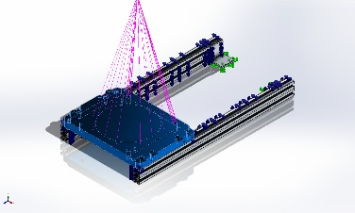 | Solid Body | Mass:4.47233 kg  Volume:0.00165642 m^3  Density:2,700 kg/m^3  Weight:43.8288 N | C:\Users\Lucas\Documents\Projects\Co_Printing\RAAM\Layout\Grundplatte Typ L - H35mm_V03.SLDPRT  Oct 2 12:14:19 2025

Study Properties
Study name | Static 1
Analysis type | Static
Mesh type | Solid Mesh
Thermal Effect: | On
Thermal option | Include temperature loads
Zero strain temperature | 298 Kelvin
Include fluid pressure effects from SOLIDWORKS Flow Simulation | Off
Solver type | Automatic
Inplane Effect: | Off
Soft Spring: | Off
Inertial Relief: | Off
Incompatible bonding options | Automatic
Large displacement | Off
Compute free body forces | On
Friction | Off
Use Adaptive Method: | Off
Result folder | SOLIDWORKS document (C:\Users\Lucas\Documents\Projects\Co_Printing\RAAM\Layout)

Units
Unit system: | SI (MKS)
Length/Displacement | mm
Temperature | Kelvin
Angular velocity | Rad/sec
Pressure/Stress | N/m^2

Material Properties
<Label_ModelReference/> | <Label_Properties/> | <Label_Components/>
<Image_144pxH_Material1/> | <Label_MatName/>: <Material_Name1/> | <Material_ComponentList1/>
<MatImagesRow1/>
<Label_CurveData/>::
<Curve_1_1/> | <Curve_1_2/> | <Curve_1_3/>
<Curve_1_1_Label/> | <Curve_1_2_Label/> | <Curve_1_3_Label/>
<Curve_1_4/> | <Curve_1_5/> | <Curve_1_6/>
<Curve_1_4_Label/> | <Curve_1_5_Label/> | <Curve_1_6_Label/>

Loads and Fixtures
Fixture name | Fixture Image | Fixture Details
Fixed-1 | 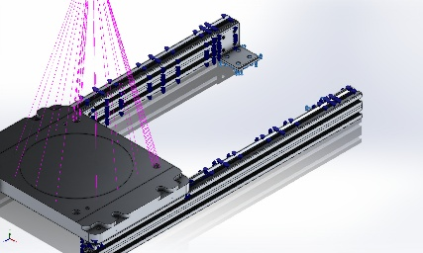 | Entities: 4 face(s)  Type: Fixed Geometry
Resultant Forces
Components | X | Y | Z | Resultant
Reaction force(N) | 5.32032e-05 | 542.998 | 0.00117283 | 542.998
Reaction Moment(N.m) | 0 | 0 | 0 | 0

Load name | Load Image | Load Details
Remote Load (Distributed connection)-1 | 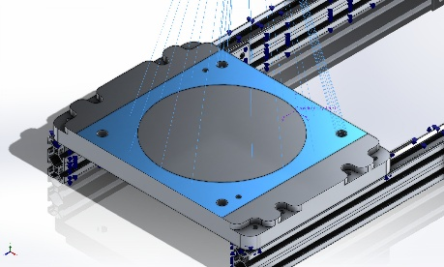 | Entities: 1 face(s)  Connection Type: Distributed  Weighting Factor: Default (Constant)  Coordinate System: Coordinate System1  Translational Components: ---,-543 N,---  Rotational Components: ---,---,---  Reference coordinates: 0 437 75 mm

Connector Definitions

Connector Name | Connector Details | Connector Image
Rigid Connector-1 | Entities: 3 face(s)  Type: Rigid | 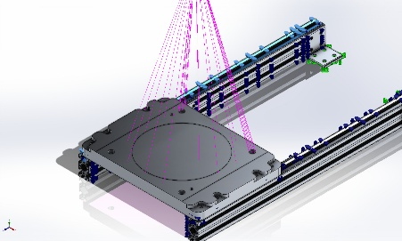  Rigid Connector-1
Rigid Connector-2 | Entities: 3 face(s)  Type: Rigid | 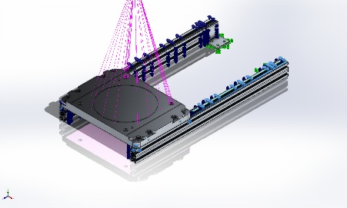  Rigid Connector-2
Rigid Connector-3 | Entities: 6 face(s)  Type: Rigid | 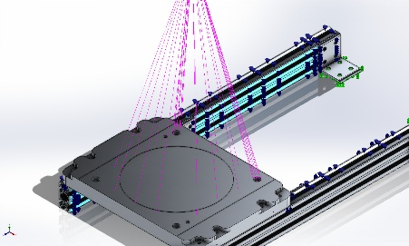  Rigid Connector-3
Rigid Connector-4 | Entities: 6 face(s)  Type: Rigid | 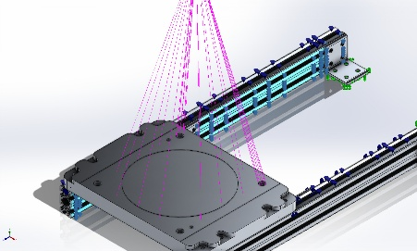  Rigid Connector-4
Rigid Connector-5 | Entities: 6 face(s)  Type: Rigid | 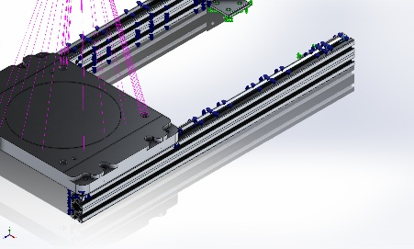  Rigid Connector-5
Rigid Connector-6 | Entities: 6 face(s)  Type: Rigid | 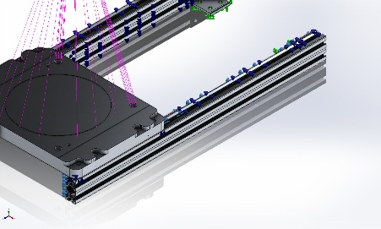  Rigid Connector-6

Interaction Information

Interaction | Interaction Image | Interaction Properties
Global Interaction | 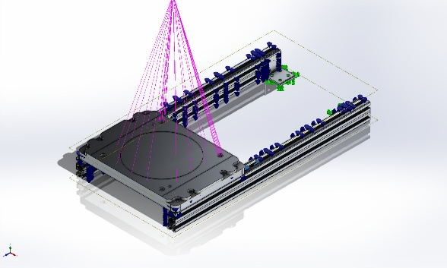 | Type: Bonded  Components: 1 component(s)  Options: Independent mesh

Mesh information
Mesh type | Solid Mesh
Mesher Used: | Blended curvature-based mesh
Jacobian points for High quality mesh | 16 Points
Maximum element size | 17.2187 mm
Minimum element size | 0.860934 mm
Mesh Quality | High
Remesh failed parts independently | Off
Reuse mesh for identical parts in an assembly (Blended curvature-based mesher only) | Off

Mesh information - Details
Total Nodes | 4590314
Total Elements | 2772632
Maximum Aspect Ratio | 67.892
% of elements with Aspect Ratio < 3 | 92.2
Percentage of elements with Aspect Ratio > 10 | 0.579
Percentage of distorted elements | 0
Time to complete mesh(hh;mm;ss): | 00:03:09
Computer name: | IP-5-FLEX

Mesh Quality Plots
Name | Type | Min | Max
Quality1 | Mesh | - | -
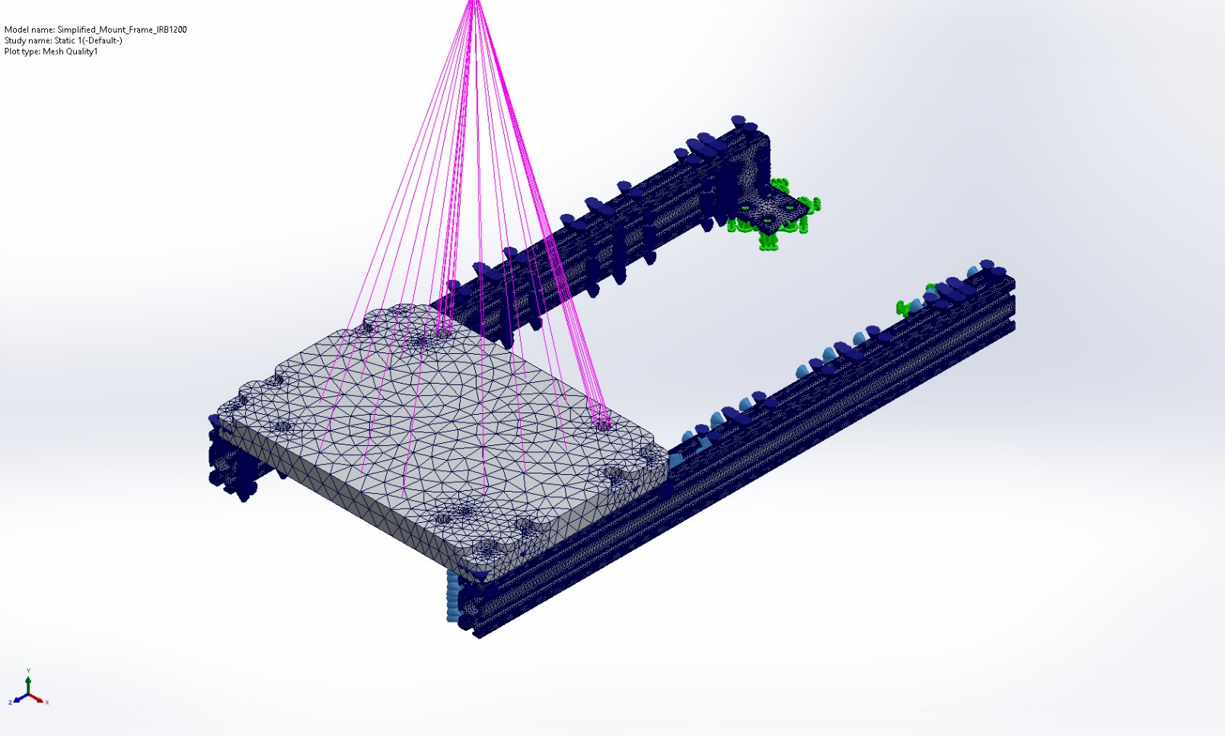
Simplified_Mount_Frame_IRB1200-Static 1-Quality-Quality1

Sensor Details
No Data

Resultant Forces

Reaction forces
Selection set | Units | Sum X | Sum Y | Sum Z | Resultant
Entire Model | N | 5.32032e-05 | 542.998 | 0.00117283 | 542.998

Reaction Moments
Selection set | Units | Sum X | Sum Y | Sum Z | Resultant
Entire Model | N.m | 0 | 0 | 0 | 0

Free body forces
Selection set | Units | Sum X | Sum Y | Sum Z | Resultant
Entire Model | N | -0.00678599 | -0.0184344 | 0.00430669 | 0.0201103

Free body moments
Selection set | Units | Sum X | Sum Y | Sum Z | Resultant
Entire Model | N.m | 0 | 0 | 0 | 1e-33

Beams
No Data

Study Results

Name | Type | Min | Max
Stress1 | VON: von Mises Stress | 1.208e-04N/m^2  Node: 3985053 | 3.308e+07N/m^2  Node: 4366306
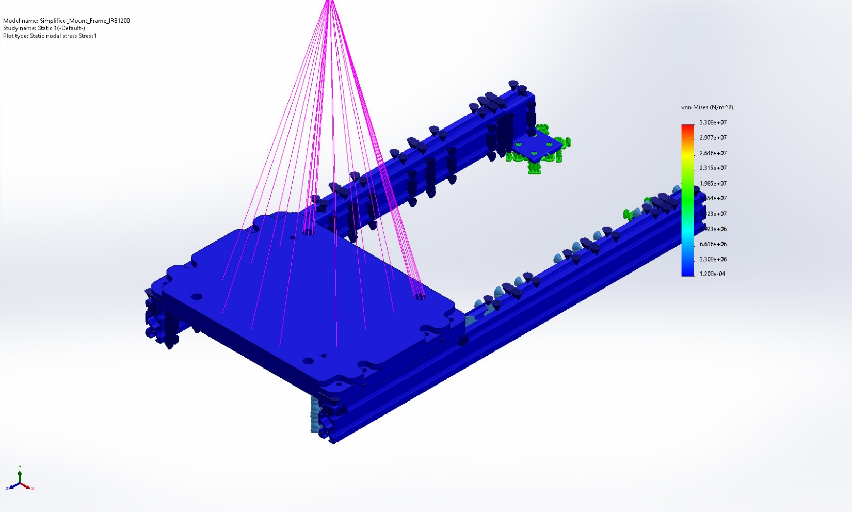
Simplified_Mount_Frame_IRB1200-Static 1-Stress-Stress1

Name | Type | Min | Max
Displacement1 | URES: Resultant Displacement | 0.000e+00mm  Node: 4014589 | 1.497e-04mm  Node: 4553431
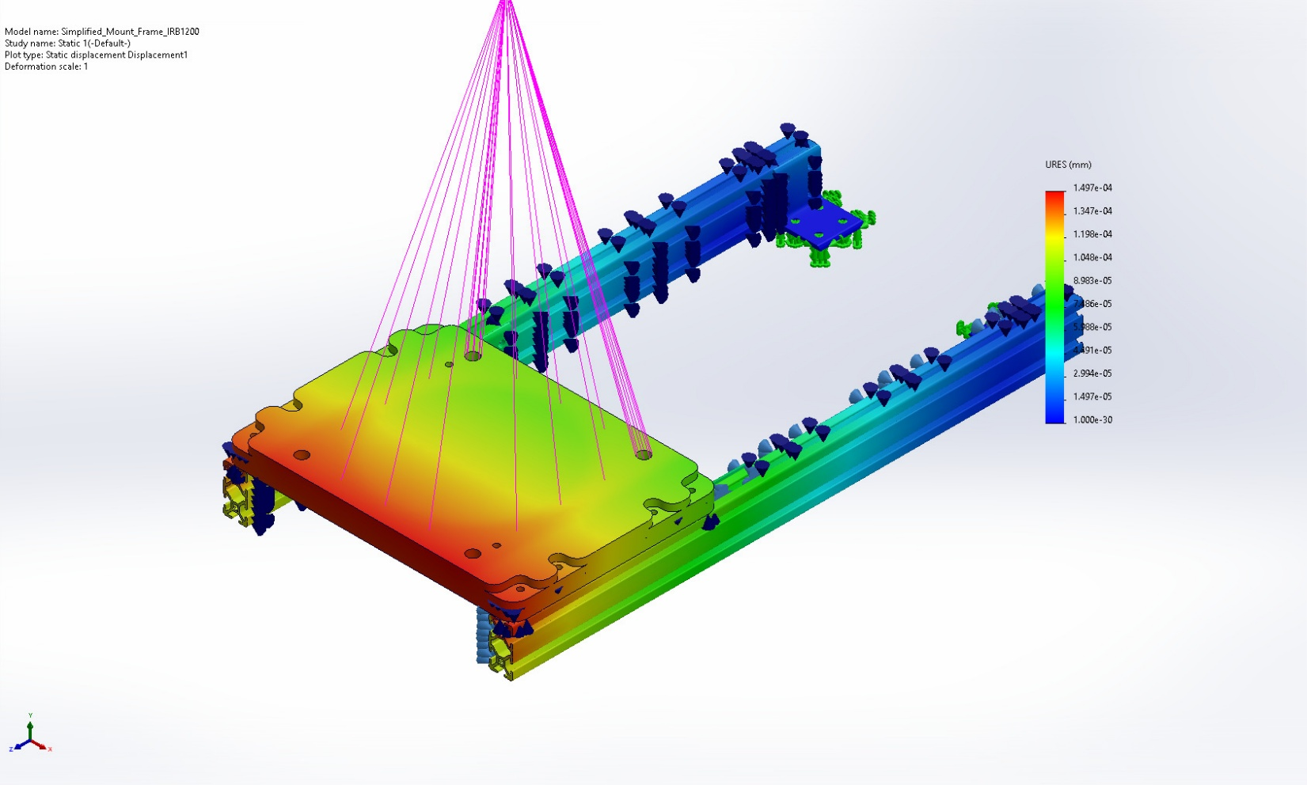
Simplified_Mount_Frame_IRB1200-Static 1-Displacement-Displacement1

Name | Type | Min | Max
Strain1 | ESTRN: Equivalent Strain | 1.661e-15  Element: 2679914 | 2.096e-04  Element: 2640853
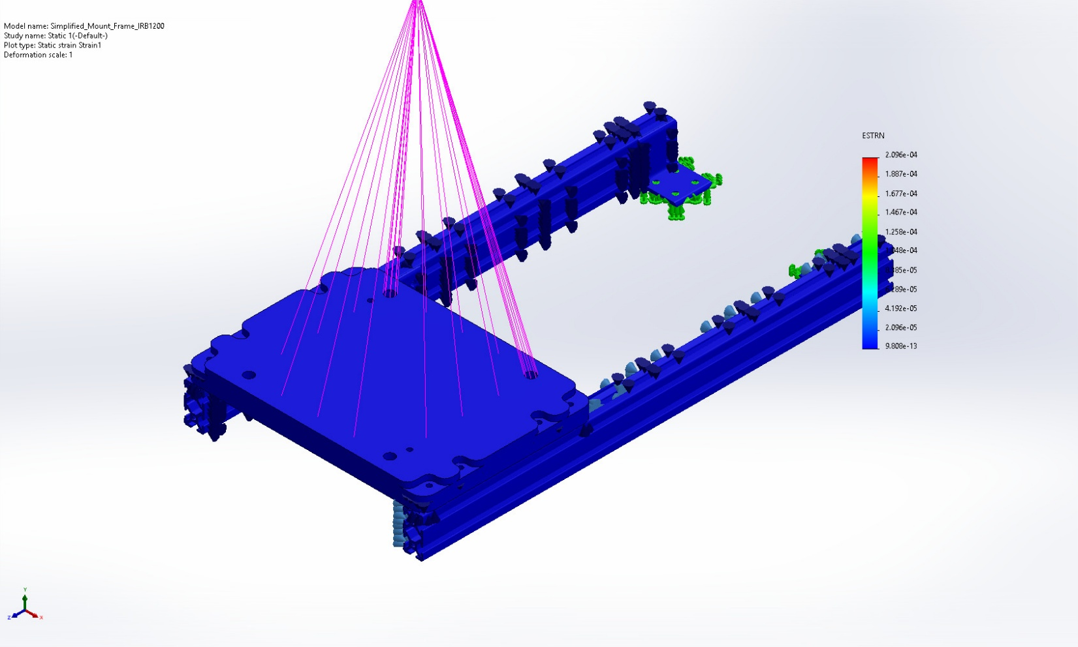
Simplified_Mount_Frame_IRB1200-Static 1-Strain-Strain1

Name | Type | Min | Max
Factor of Safety1 | Automatic | 6.500e+00  Node: 4366306 | 4.222e+09  Node: 1914078
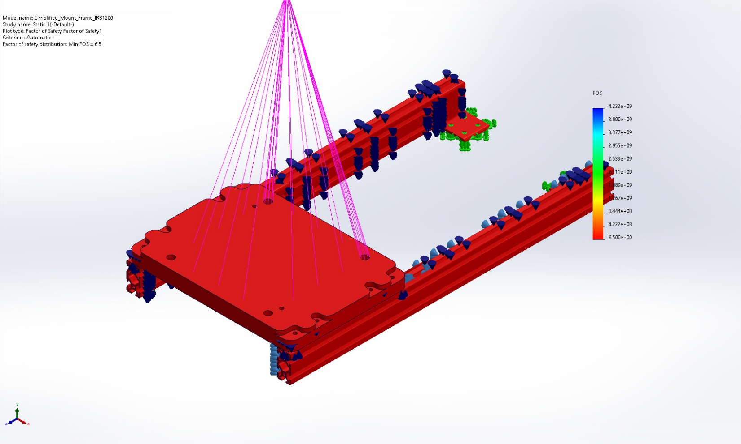
Simplified_Mount_Frame_IRB1200-Static 1-Factor of Safety-Factor of Safety1

Conclusion

